**Answer1:** Excel workbook creation for class “**WriteExcel”** (Package : “**ExcelFile”**)

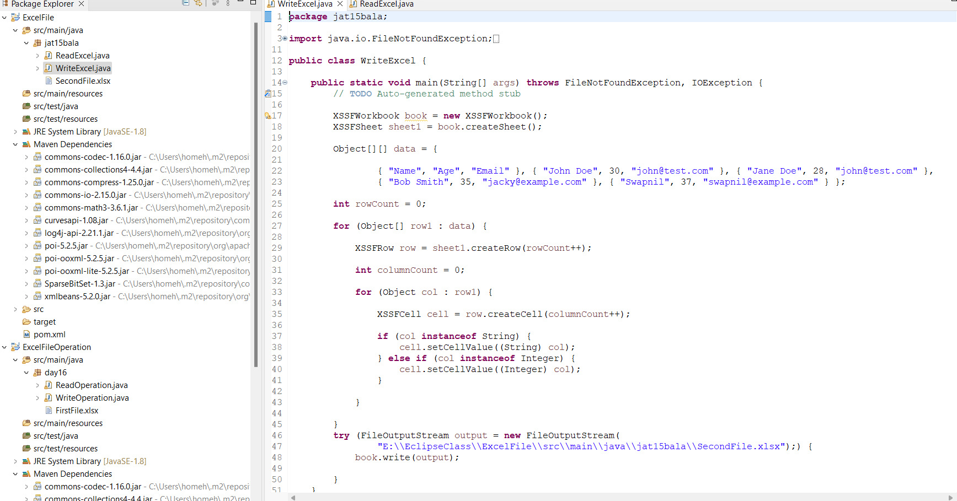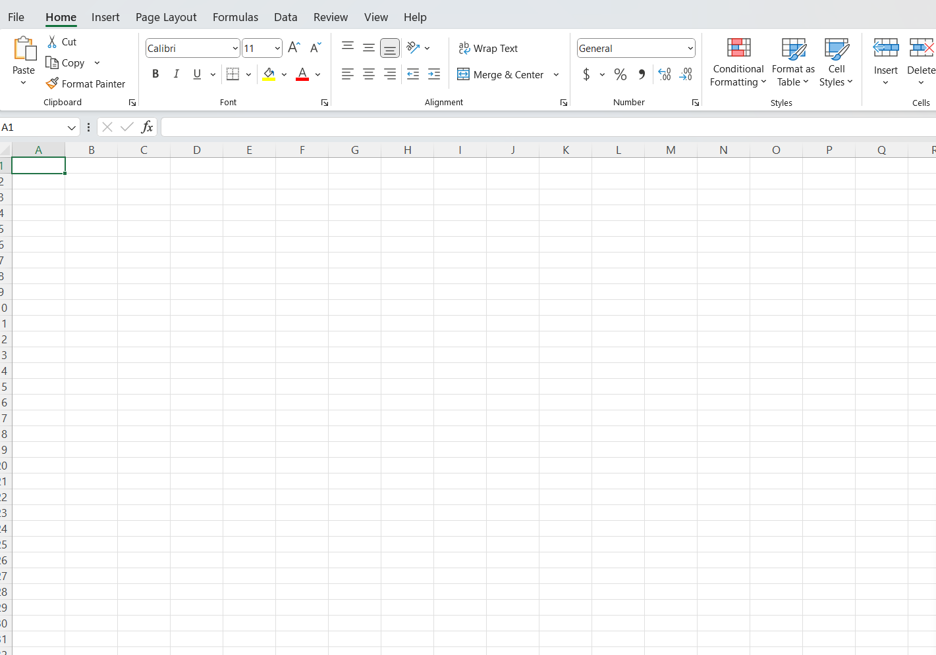

**Answer2:** New sheet with name “Sheet1” creation for class “**WriteExce”l** (Package : “**ExcelFile”**)

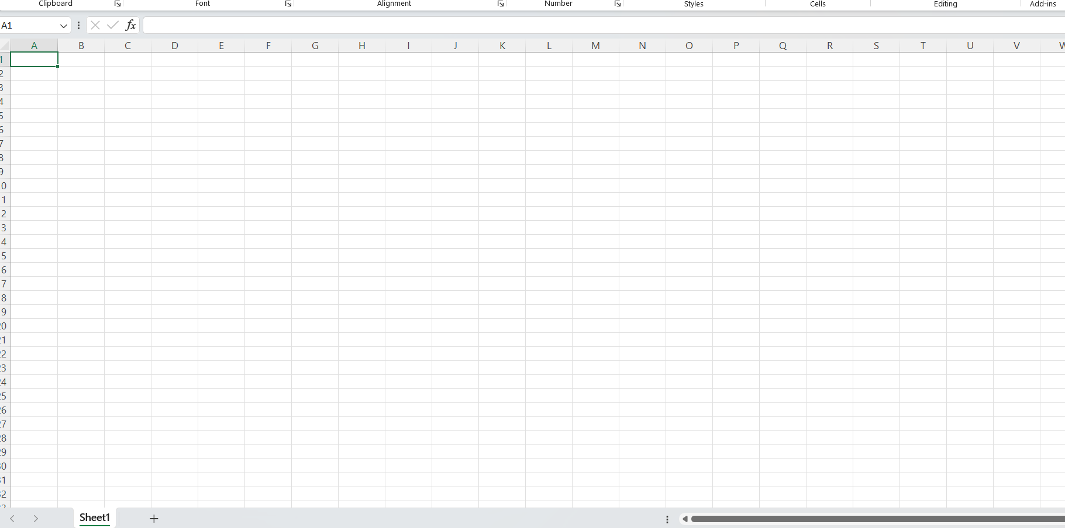

**Answer3:** data written in the sheet for class “**WriteExcel”** (Package :” **ExcelFile”**)

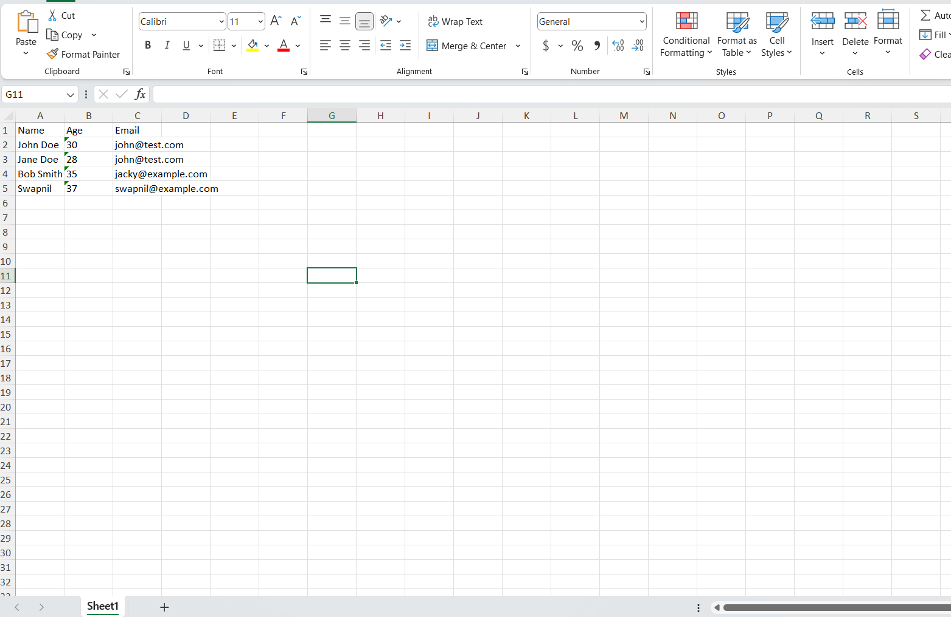

**Answer4:** class name is “**WriteExcel”** and file name is “**SecondFile”**

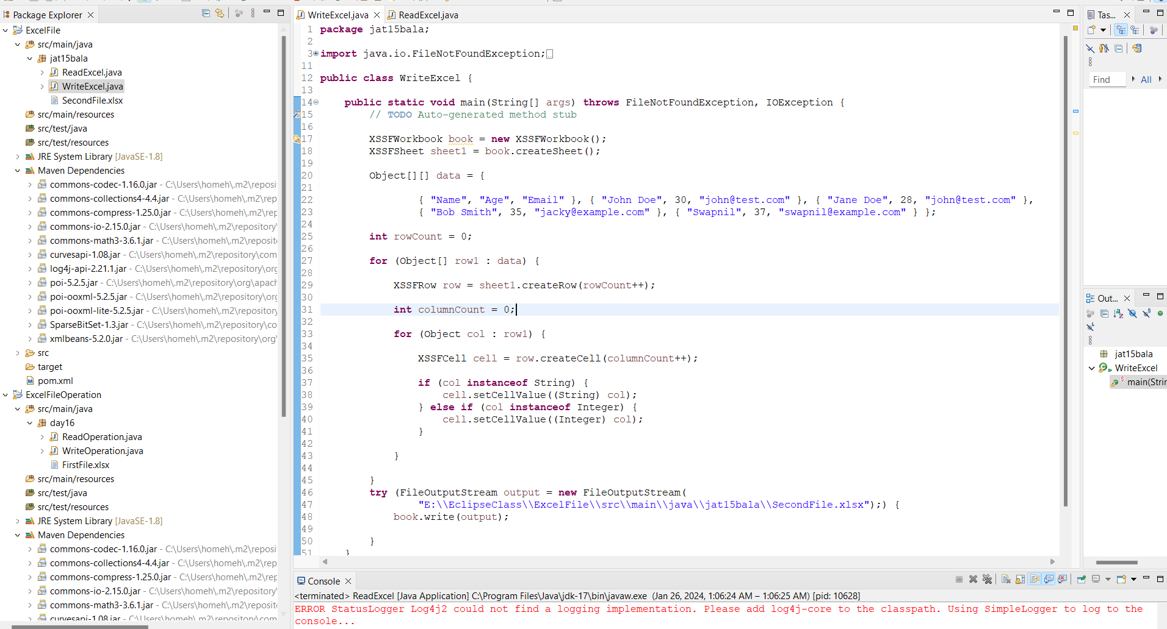

**Answer5:** class name is “**ReadExcel**”

